Identical Rhyme

🔹 What is Identical Rhyme
# Source: AI Source: Provided by: [Data Path: Persons Table -> ID Column: 1, Name_En Column: Motasem Essam] -> From: [Chatgpt (GPT-4-turbo)] on [8/1/2025]
An identical rhyme occurs when two words sound exactly the same — including both the stressed vowel and all following sounds — and often share the same spelling or are homophones (same sound, different meaning or spelling).
It goes beyond perfect rhyme by repeating the same sound entirely, rather than just rhyming the final syllable.

🧱 Types of Identical Rhyme
# Source: AI Source: Provided by: [Data Path: Persons Table -> ID Column: 1, Name_En Column: Motasem Essam] -> From: [Chatgpt (GPT-4-turbo)] on [8/1/2025]
- Same Word Repeated
  - Example: hill / hill
- Homophones (Same Sound, Different Meaning or Spelling)
  - Example: bare / bear, knight / night
- Homographic Homophones (Same Sound & Spelling, Different Meaning)
  - Example: lead / lead (as in “to lead” vs. “the metal lead”)

📝 Examples
# Source: AI Source: Provided by: [Data Path: Persons Table -> ID Column: 1, Name_En Column: Motasem Essam] -> From: [Chatgpt (GPT-4-turbo)] on [8/1/2025]
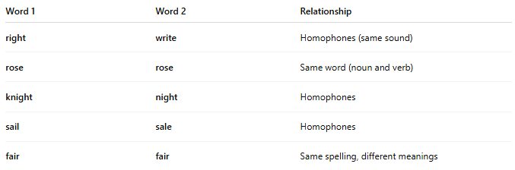
Word 1 | Word 2 | Relationship
right | write | Homophones (same sound)
rose | rose | Same word (noun and verb)
knight | night | Homophones
sail | sale | Homophones
fair | fair | Same spelling, different meanings

🎨 Poetic Effect
# Source: AI Source: Provided by: [Data Path: Persons Table -> ID Column: 1, Name_En Column: Motasem Essam] -> From: [Chatgpt (GPT-4-turbo)] on [8/1/2025]
- Often deliberate repetition for emphasis, wordplay, or irony.
- May be used in puns, refrains, or thematic reinforcement.
- Not usually considered a “true” rhyme in strict poetic analysis due to lack of sound variation.

❌ Not the Same as:
# Source: AI Source: Provided by: [Data Path: Persons Table -> ID Column: 1, Name_En Column: Motasem Essam] -> From: [Chatgpt (GPT-4-turbo)] on [8/1/2025]
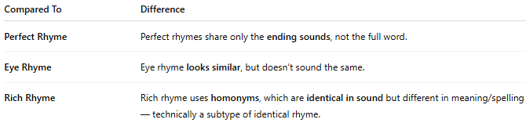
Compared To | Difference
Perfect Rhyme | Perfect rhymes share only the ending sounds, not the full word.
Eye Rhyme | Eye rhyme looks similar, but doesn’t sound the same.
Rich Rhyme | Rich rhyme uses homonyms, which are identical in sound but different in meaning/spelling — technically a subtype of identical rhyme.

🗒️ Used In
# Source: AI Source: Provided by: [Data Path: Persons Table -> ID Column: 1, Name_En Column: Motasem Essam] -> From: [Chatgpt (GPT-4-turbo)] on [8/1/2025]
- Refrains in poetry and music.
- Spoken word, where sound repetition adds rhythm or meaning.
- Wordplay and riddles.

